**Program Proposal**

**CPG108P**

*Performance-Based Task #1*

**Section:** I1201

**Group Members:**

* Bugarin, Alfonso
* Cruz, Euone
* Gelena, Elizabeth
* Natividad, Chloe
* Olayvar, Hannali (L)
* Sison, Janelle Louise

1. **Proposed Program:**

Multi-User Cashier Management System

1. **Program Overview**

**Description**

A modern cashier system that allows multiple users to manage transactions, inventory, and orders.

**Objective**

To help small businesses by providing them with a customizable digital cashier.

**System Functions**

* Account Creation: Create own login credentials
* Company Creation: Create own Company business
* Admin Privileges: Administrators can edit program details such as company information, business logo, color theme, etc.
* Custom Products: Users can add custom products with details including price and pictures.
* Receipt Customization: Ability to customize receipt details.
* Additional Expenses: Option to include additional expenses in transactions.
* Taxes: Functionality to incorporate taxes into transactions.
* Categorization: Users can create custom categories for products to organize products efficiently.
* Search and Filter: Search and filter functionality to easily find products and transactions.
* User Management: Admins can add other users and manage their access to the company's cashier system.

**Implementation Steps**

1. Initialize Git

-Initialize GIT repository for collaborative work on the project

1. System Design

-Create draft for the basic infrastructure for the Ordering System.

-Drafting of database

1. Database Setup

-Create dbase in MS Access

-recreate in MySQL

1. Create C# Forms

-Design intuitive user interfaces for easy navigation and usage.

1. Functionality

-Code to add functionality to the application

-Connect database through it

-Code utility classes for general usage

1. Testing and Bug Fixing

-Conduct thorough testing to ensure system functionality and reliability.

1. Deployment

-Deploy the Ordering System for use by small businesses.

1. **Program Repository**

View this link for the following: [Github Repo](https://github.com/programmerlia/cashier-management-system.git)

* [Relationship Diagram PDF](https://github.com/programmerlia/cashier-management-system/blob/main/cms-Relationship-diagram.pdf)
* [ERD PDF](https://github.com/programmerlia/cashier-management-system/blob/main/cms-ER-Diagram.pdf)
* [System Design PDF](https://github.com/programmerlia/cashier-management-system/blob/main/cms-System-Design.pdf)
* [Database/Accdb File](https://github.com/programmerlia/cashier-management-system/blob/main/dbase.accdb)

*For clearer images, check the original files in the repository above

1. **Entity Relationship Diagram**

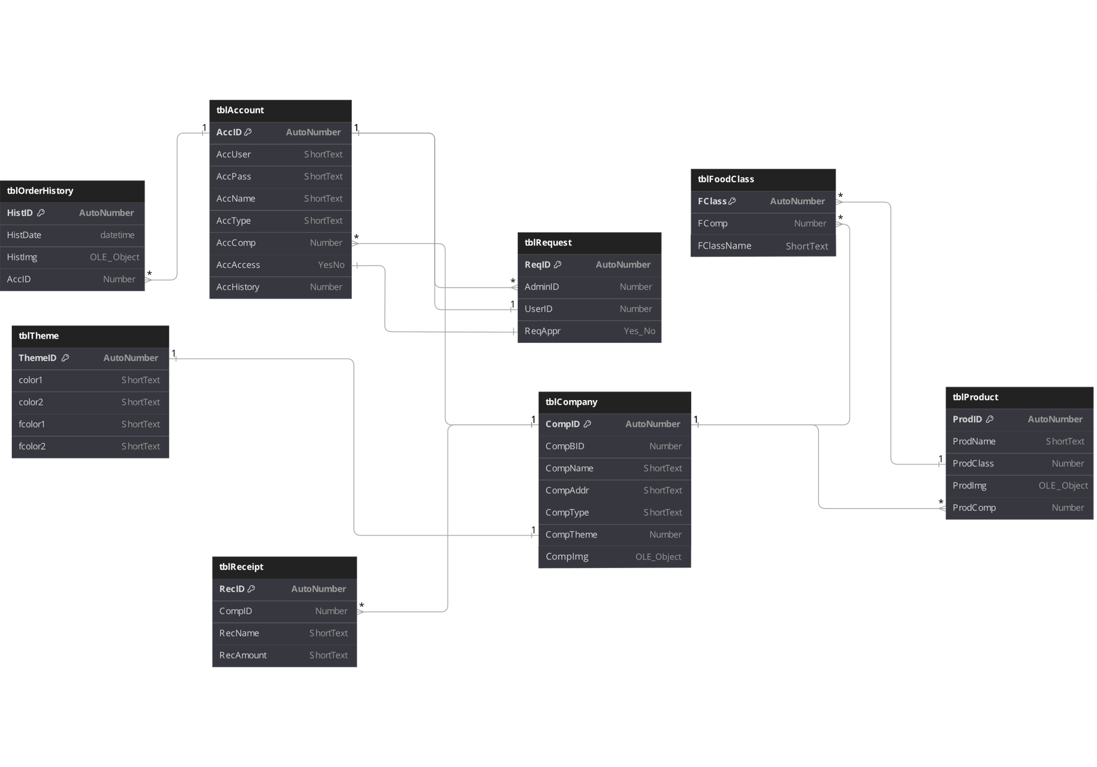

1. **System Design**

